Statistical Inference Project

Simulation Exercise
Overview In this we investigate the exponential distribution in R and compare it with the Central Limit Theorem. The exponential distribution can be simulated in R with rexp(n, lambda) where lambda is the rate parameter. The mean of exponential distribution is 1/lambda and the standard deviation is also 1/lambda. Set lambda = 0.2 for all of the simulations. We investigate the distribution of averages of 40 exponentials. Note that we do a thousand simulations.
Part 1: Show the sample mean and compare it to the theoretical mean distribution
n <- 40
Simulations <- 1000
Lambda <- 0.2
SampleMean <- NULL for(i in 1:Simulations) {
SampleMean <- c(SampleMean, mean(rexp(n, Lambda)))
} mean(SampleMean)
## [1] 4.991318
Part 2: Show the sample is (via variance) and compare it to the thoretical variance of the
distribtution
Variance <- var(SampleMean)
Variance
## [1] 0.6574795
Part 3: Show that the distribution is appoximately normal
hist(SampleMean, breaks = n, prob = T, col = "turquoise", xlab = "Means") x <- seq(min(SampleMean), max(SampleMean), length = 100) lines(x, dnorm(x, mean = 1/Lambda, sd = (1/Lambda/sqrt(n))), pch = 25, col = "black")
Histogram of SampleMean
Density
0.0
0.1
0.2
0.3
0.4
0.5
3 4 5 | 6 7 8  Means
qqnorm(SampleMean)
qqline(SampleMean, col = "red")
Normal Q−Q Plot
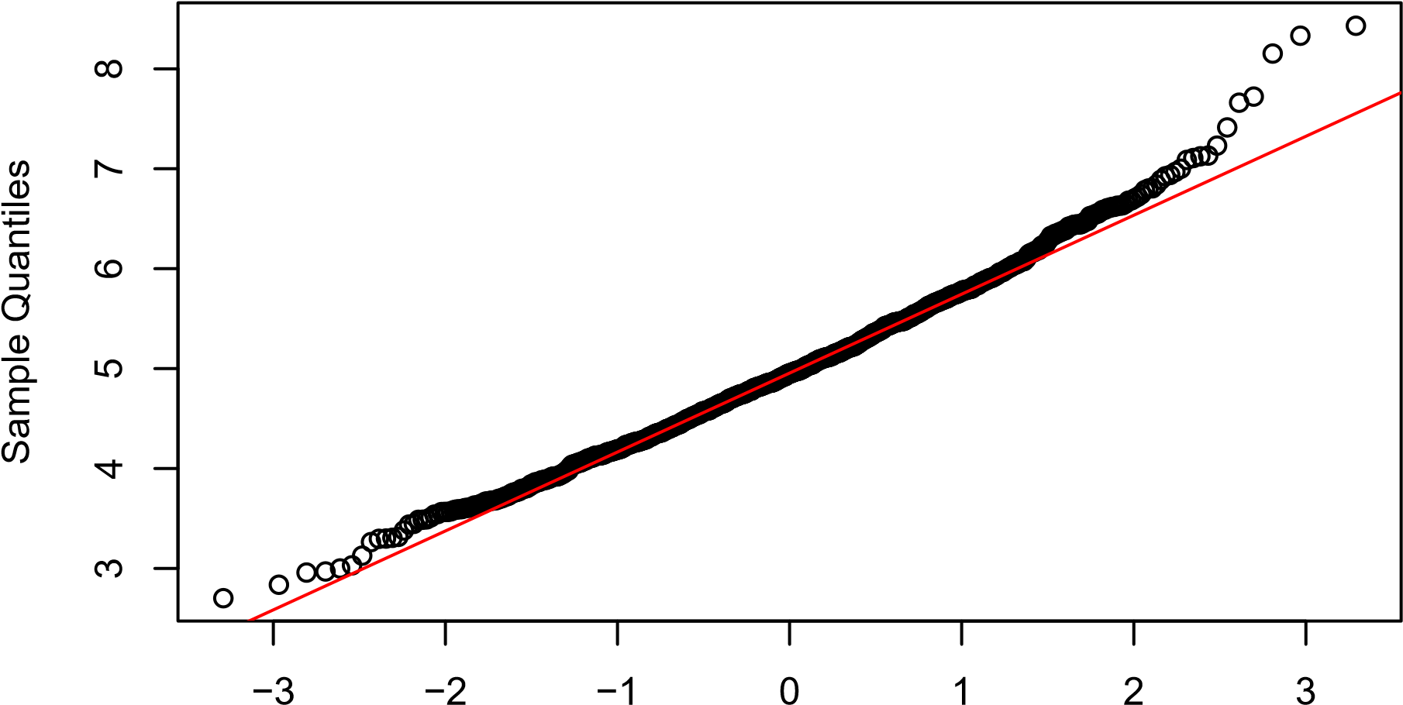
Theoretical Quantiles
The distribution averages of 40 exponentials is very close to a normal distribution.

Basic Inferential Data Ananlysis
We will analyze the ToothGrowth data in the R datasets package.
- Load the ToothGrowth data and perform some basic exploratory data analysis
library(datasets) data(ToothGrowth) library(ggplot2) str(ToothGrowth)
## ’data.frame’: 60 obs. of 3 variables:
## $ len : num 4.2 11.5 7.3 5.8 6.4 10 11.2 11.2 5.2 7 ...
## $ supp: Factor w/ 2 levels "OJ","VC": 2 2 2 2 2 2 2 2 2 2 ...
## $ dose: num 0.5 0.5 0.5 0.5 0.5 0.5 0.5 0.5 0.5 0.5 ...
- Look at the data set
head(ToothGrowth)
## len supp dose
## 1 4.2 VC 0.5
## 2 11.5 VC 0.5
## 3 7.3 VC 0.5
## 4 5.8 VC 0.5
## 5 6.4 VC 0.5
## 6 10.0 VC 0.5
summary(ToothGrowth)
## len supp dose
## Min. : 4.20 OJ:30 Min. :0.500
## 1st Qu.:13.07 VC:30 1st Qu.:0.500
## Median :19.25 Median :1.000
## Mean :18.81 Mean :1.167
## 3rd Qu.:25.27 3rd Qu.:2.000
## Max. :33.90 Max. :2.000
- Plotting the data
ggplot(data=ToothGrowth, aes(x=as.factor(dose), y=len, fill=supp)) + geom_bar(stat="identity") + facet_grid(. ~ supp) + xlab("Dose(mg)") + ylab("Tooth length")
OJ
VC
0.5
1
2
0.5
1
2
0
100
200
Dose(mg)
Tooth length
supp
OJ
VC
- Use confidence intervals and/or hypothesis tests to compare tooth growth by supp and dose.
hypoth1 <- t.test(len ~ supp, data = ToothGrowth) hypoth1$conf.int
## [1] -0.1710156 7.5710156
## attr(,"conf.level") ## [1] 0.95
hypoth1$p.value
## [1] 0.06063451
hypoth2<-t.test(len ~ supp, data = subset(ToothGrowth, dose == 0.5)) hypoth2$conf.int
## [1] 1.719057 8.780943
## attr(,"conf.level") ## [1] 0.95
hypoth2$p.value
## [1] 0.006358607
hypoth3<-t.test(len ~ supp, data = subset(ToothGrowth, dose == 1)) hypoth3$conf.int
## [1] 2.802148 9.057852
## attr(,"conf.level") ## [1] 0.95
hypoth3$p.value
## [1] 0.001038376
hypoth4<-t.test(len ~ supp, data = subset(ToothGrowth, dose == 2)) hypoth4$conf.int
## [1] -3.79807 3.63807
## attr(,"conf.level") ## [1] 0.95
hypoth4$p.value
## [1] 0.9638516

Conclusion
OJ ensures more tooth growth than VC for dosages 0.5 & 1.0. OJ and VC gives the same amount of tooth growth for dose amount 2.0 mg/day. For the entire trail we cannot conclude OJ is more effective that VC for all scenarios.

